**FDIC (Federal Deposit Insurance Deposit Corporation)**

The Federal Deposit Insurance Corporation (FDIC) is an independent agency created by Congress to maintain stability and public confidence in the nation's financial system.

|  |  |
| --- | --- |
| **Covered by FDIC insurance** | **Not Covered by FDIC insurance** |
| Checking Accounts  Ex-Sofi, axos,nbkc | Bond investments  Ex-Municipal ,Corporate Bonds |
| Negotiable order of withdrawal (NOW) accounts Available in Citi ,Wells Fargo banks | Mutual funds  Ex- Fidelity Contrafund (FCNTX), Franklin DynaTech Fund |
| Savings accounts  Available in banks and credit unions | Crypto assets  Ex- Bitcoin ,Ripple, Solana |
| Money market deposit accounts (MMDAs)  Available in banks and credit unions | Life insurance policies Annuities  Term Life Insurance ,Whole Life Insurance ,Fixed Annuity ,Variable Annuity |
| Time deposits such as certificates of deposit (CDs)  Available in banks and credit unions | Municipal securities  General Obligation Bonds ,Revenue Bonds |
| Cashier's checks (Bank of America ,Wells Fargo), money orders (United States Postal Service , Walmart), and other official items issued by a bank | Safe deposit boxes or their contents  Available in banks and credit unions  Important Documents ,Financial Documents |
| Some FBO (For Benefit Of) accounts  Brokerage Account (FBO Client) ,Bank Custodial Account (FBO Depositor) | US Treasury bill  4-week (1-month) Treasury Bills,4-week (1-month) Treasury Bills |
| Some DACAs (Deposit Account Control Agreements)  Commercial Real Estate Financing ,Asset-Based Lending | Stock Investments  Technology Sector ,Healthcare Sector |

The FDIC is headquartered in Washington, DC, and has established regional and field offices around the country.

The FDIC is managed by a five-person Board of Directors that includes the Comptroller of the Currency and the Director of the Consumer Financial Protection Bureau, all of whom are appointed by the President and confirmed by the Senate, with no more than three being from the same political party.

An independent agency of the federal government, the FDIC was created in 1933 in response to the thousands of bank failures that occurred in the 1920s and early 1930s.

The standard insurance amount is $250,000 per depositor, per insured bank, for each account ownership category.

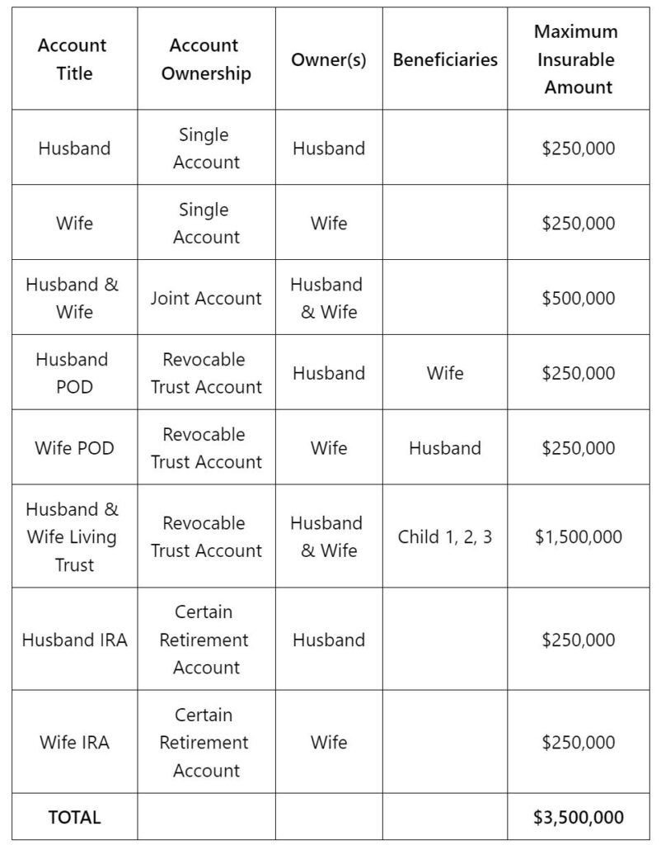

**OCC (Office Of The Comptroller Of The Currency)**

The Office of the Comptroller of the Currency (OCC) is an independent bureau of the U.S. Department of the Treasury. The OCC charters, regulates, and supervises all national banks, federal savings associations, and federal branches and agencies of foreign banks.

The Office of the Comptroller of the Currency (OCC) was created as a bureau of the U.S. Department of the Treasury by the National Currency Act of February 25, 1863.

* Mr Michael J. Hsu became Acting Comptroller of the Currency on May 10, 2021.
* It supervises nearly 1,100 national banks, federal savings associations, and federal branches and agencies of foreign banks that serve consumers, businesses, and communities across the United States.
* Headquartered in Washington, D.C., the OCC has offices nationwide.

The OCC is conducting exploratory reviews at banks with $100 billion or more in total consolidated assets to develop a baseline understanding of the banks' climate-related financial risk management.

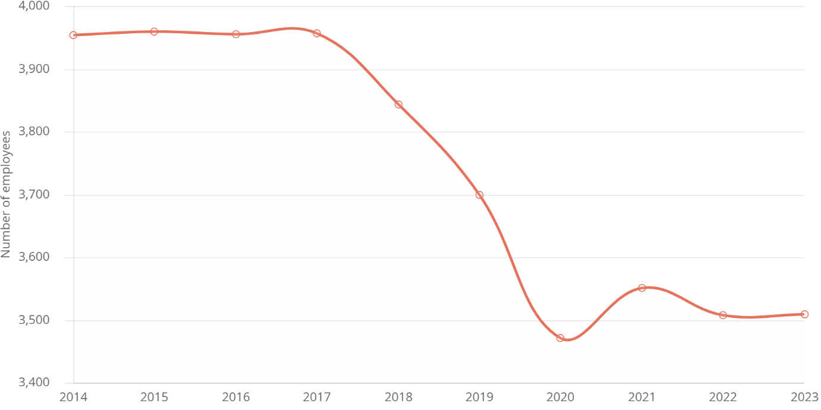

**Federal Reserve System**

The U.S. central banking system—the Federal Reserve, or the Fed—is the most powerful economic institution in the United States, perhaps the world. Its core responsibilities include setting interest rates, managing the money supply, and regulating financial markets.

It also acts as a lender of last resort during periods of economic crisis, as demonstrated during the 2008 financial meltdown and the COVID-19 pandemic. In the wake of Russia’s invasion of Ukraine in 2022 and the ensuing spike in energy prices, the central bank has struggled with how to slow rapid inflation without damaging economic growth.

* The decision leaves the Fed’s benchmark short-term rate at a 23-year high of 5.25% to 5.5% for a fifth straight meeting.
* Fed officials maintained their projection that they’ll lower the federal funds rate by three-quarters of a percentage point to a range of 4.5% to 4.75% by year’s end, according to their median estimate.

The system's 12 regional Federal Banks are based in Boston, New York, Philadelphia, Cleveland, Richmond, Atlanta, Chicago, St. Louis, Minneapolis, Kansas City, Dallas, and San Francisco. Headquartered in Washington, D.C..

**The Fed performs five general functions:**

Conducting the nation's monetary policy

Regulating banking institutions

Monitoring and protecting the credit rights of consumers

Maintaining the stability of the financial system

Providing financial services to the U.S. government

